Pearl Ayem – 34404160

**ATSC 303 Lab 2 - Thermometer lab**

**Methods:**

Two thermocouples of unknown sensitivity were constructed. Each thermocouple was then exposed to different temperatures to log the changes in temperature(℃ ) and voltage (µV) measured. This data was plotted to find the sensitivity and therefore determine the types of each thermocouple. A CR1000 data logger was used, along with the LoggerNet software to store this data. My group members in this lab were Andersen Ko, Darian Ng and Nathalie Buu. The purple wired thermocouple was inserted in channel 2, and blue wire in channel 3.

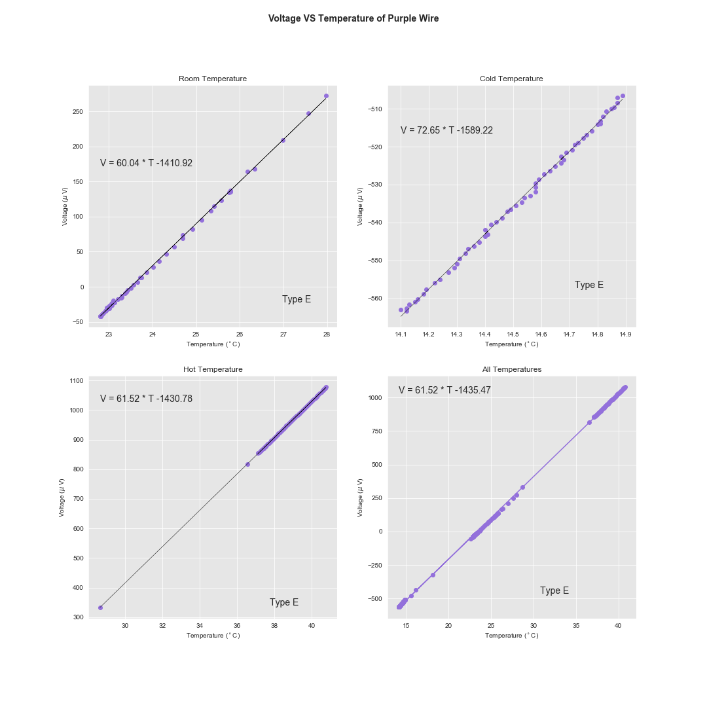**Results:**

The graphs generated from this lab are attached below as figure 1 for the purple wire and figure 2 for the blue wire, respectively. Figure 1 shows that as temperature increases in the thermocouple, the voltage also increases. Specifically, the room temperature measurements predict that voltage would increase by 60.04µV per ℃. The overall trend stated that the purple wire thermocouple was a Type E because it increased by an overall 61.52 µV per ℃.

Figure 1: Purple wire voltage versus temperature graphs

Figure 2 shows that as temperature increases in the thermocouple, the voltage also increases. Specifically, the room temperature measurements predict that voltage would increase by 40.18 µV per ℃ increase in temperature. For cold water this is 49.0 µV per ℃ and hot water it is 41.46 µV per ℃ The overall trend stated that the purple wire thermocouple was a Type T because it increased by an overall 41.11 µV per ℃.

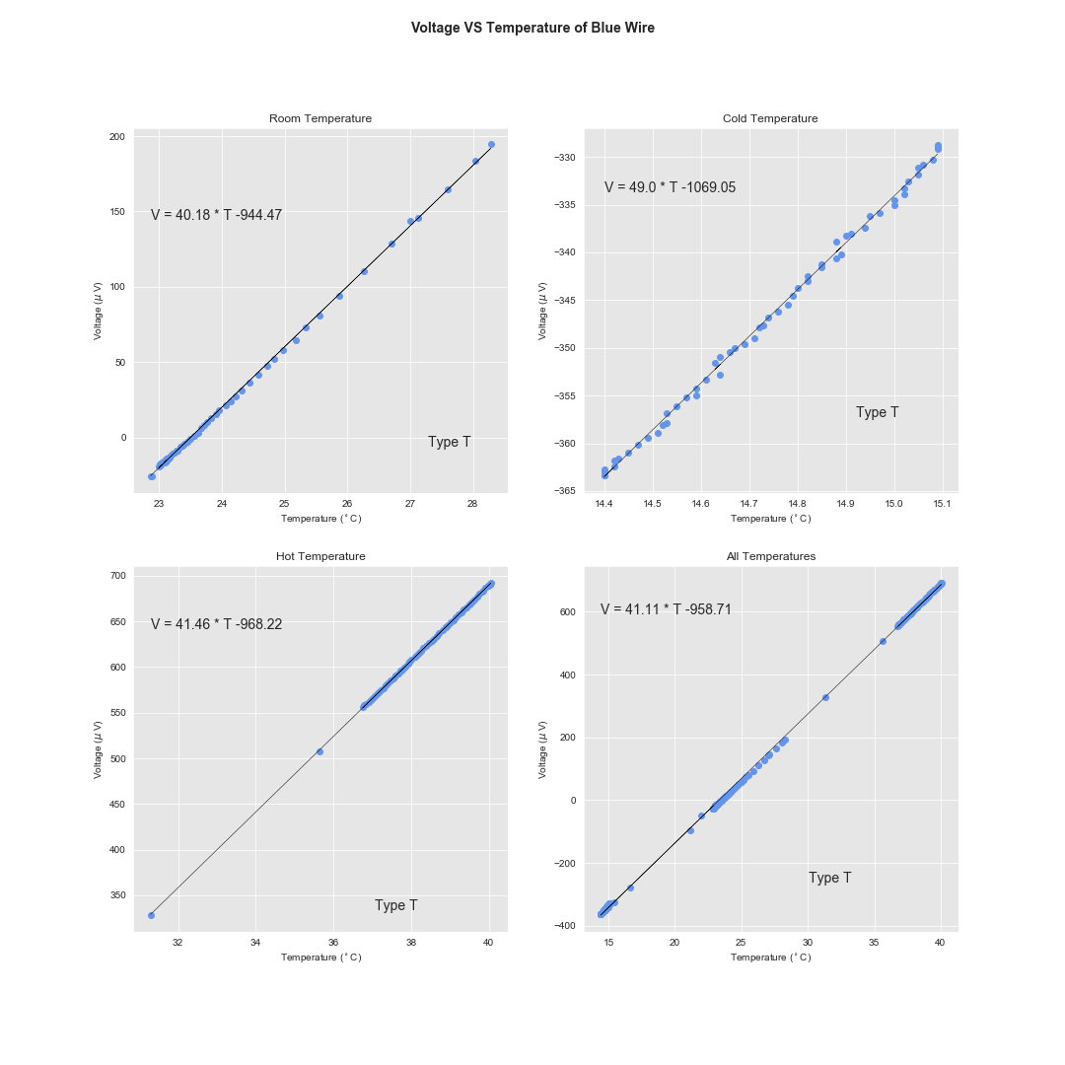

Figure 2: Blue wire volatage vs temperature graphs

**Analysis and Discussion:**

There was a very clear distinction between the two thermocouple types from the data generated. It was seen that the sensors were very sensitive to small temperature changes. However, the output voltage is relatively small as it is measured in microvolts. Some errors in this design include small time lag – this is seen in the Hot Temperature plot of Figure 1, where there is an outlier at 28℃ before detecting temperature increase. This is a dynamic error. There was also drift since hot water gets cooler and cold water gets warmer over time so a perfect linear trend is hard to generate. The room temperature measurement was done not at a constant neutral temperature but measured the air, whereas the other temperatures used were measuring water temperature. Therefore, rates of temperature change in each medium also differ which add to the errors.

**Questions**:

1. The temperature is the measurand, and the thermocouples are the sensors. The outputs (y1) are the voltage readings recorded using the CR1000 datalogger. This makes the CR1000 the analog to digital convertor. This is the Y3 reading. The data logger creates an output reading every 10 seconds. Y4 is thus this discrete reading. The measurements are transferred via the laptop connection into the loggernet software where they are stored. This would be block 5. Loggernet stores these as a tabulated discrete signal, making the stored file the Y6 output. It is finally displayed when we open the saved data file.
2. They are the most commonly found due to cheaper metals used in manufacture as compared to perhaps PRTs or sonic temperature sensors. It is also very robust and one of the most portable sensors since it can be made fairly small. The provide a wide temperature range by the use to the right combination of metals for different thermocouple types. The voltage across a thermocouple is unaffected by temperatures elsewhere in the circuit; so it can use lead wires made of thermocouple metals. Finally they have a fast response time.
3. A major limitation is that the small emf produced requires a sensitive voltmeter. Additionally the temperature-voltage characteristic of a thermocouple over a large range is non-linear. Long, or unscreened connection leads can generate noise voltages comparable with thermocouple voltage, compromising the voltage. And if individual thermocouples are connected in series to create a thermopile, it is more sensitive than a single thermocouple, but may be physically larger.
4. Due to the rule three which states that if a third metal is inserted in one of the junctions, then no net voltage is generated so long as junction and third metal are at the same temperature. This means that the two wires or a junction can be soldered together and the presence of the third metal, solder, will not affect the voltage if there is no temperature gradient across the solder junction.
5. There may not end up being a very large temperature difference between the two metals if the wire is too short, and therefore the Seebeck effect will be weaker.
6. The Seebeck effect is the build up of an electric potential across a temperature gradient. A thermocouple measures the difference in potential across a hot and cold end for two dissimilar materials. This potential difference is proportional to the temperature difference between the hot and cold ends.
7. If a third metal is inserted in either wire and the two new junctions are at the same temperature, no effective voltage is generated by third metal. The terminals of a voltmeter are usually made of a third metal and can be close together. The voltage across a thermocouple is unaffected by temperatures elsewhere in the circuit, provided the two metals used are each homogeneous. Thus one can use lead wires made of thermocouple metals. It is just important to make sure the terminals of the voltmeter are at the same temperature.
8. The sensitivity of a sensor is then defined as the ratio between the output signal and measured property. For a thermocouple this sensitivity would be the change in voltage (the output signal) per unit change in temperature (the measured property)
9. No this was not a calibration measurement because in order to calibrate a thermocouple one would plot the thermocouple's voltage-temperature curve in a way that the temperatures the thermocouple is exposed to is preplanned and measured. Ideally we would pick temperatures and increase it periodically, waiting for the thermocouple to stabilize. This procedure came pretty close but in order to calibrate it could have been cleaner.
$Y= \frac{K ∆TL^{2}}{th}= \frac{(5×{10}^{-5}℃^{-1}) \left(10℃\right)*{(0.05m)}^{2}}{(0.001m)}=0.025 m=2.5cm$

$Sensitivity= \frac{V_{0}β_{d}}{πr^{2}}= \frac{(200{mm}^{3})(1.6×{10}^{-4}℃^{-1})}{π{(0.15mm)}^{2}}=0.45 mm/℃$

11. Define:
    1. Thermistor: Thermistors are temperature-sensitive semiconductors, typically metallic oxides. They are characterized by large and quite nonlinear temperature sensitivity. It is specifically fabricated so that its electrical resistance varies markedly with temperature.
    2. Centigrade scale: Celsius, also called centigrade, scale based on 0° for the freezing point of water and 100° for the boiling point of water, is a scale to measure linear change of temperature.
    3. Metal resistance thermometer: An electrical metal resistance thermometer is one whose resistance varies as a function of temperature. Electrical resistance R of a wire increases as temperature increases.
    4. Self-heating: This is the heating up of the sensors themselves due to current flowing through the sensors, generally RTDs (Resistance temperature detectors)
    5. Bimetallic strip: A bimetallic strip is a pair of metals with different thermal expansion coefficients that have been bonded together.
12. An ideal radiation shield should:
    1. Provide shielding from direct rays of the sun at all times
    2. Not affect the thermometers by warming up
    3. Prevent reflected radiation from reaching the thermometers
    4. Exclude external sources of heat (e.g. from buildings)
    5. Allow free passage of air around the thermometers.
13. There is self-heating in the wires and the reading is less accurate. There is also risk of electrical hazards.

$∆V=\left(a+b∆T\right)∆T=\left(38.6μVK^{-1}+0.0413 μVK^{-2}×10K\right)×10K=390.13μV$

$if ∆V=390.13μV then sensitivity= \frac{∆V}{∆T}= \frac{390.13μV}{10 K}=39.013μVK^{-1}$

$\frac{∆V}{∆T}= \frac{390.13μV}{40 K}=9.753 μVK^{-1}$

$BONUS$